Controls:

P – Pausing/Unpausing the Scene

PAUSE – Pausing/Unpausing the Scene rotation

WASD – moving the camera

L – Locking/Unlocking the scene’s camera

TAB – Splitscreen

LEFT ARROW – Previous Scene

RIGHT ARROW – Next Scene

1/2/3 – Selecting Scenes

7 – Toggle Sobel post processing effect

8 – Toggle contrast post processing effect

R – Reset Scene to the start

C – Show Controls on screen

F – Show features on screen

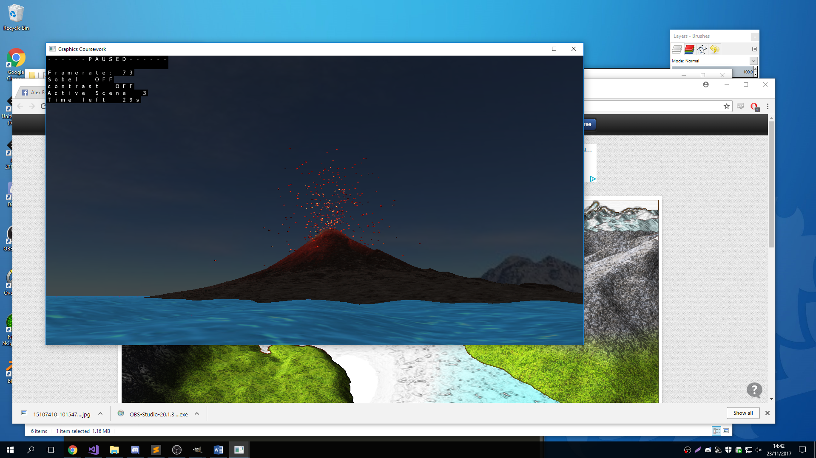

**Youtube Link:** <https://www.youtube.com/watch?v=r5ulN4dQ2RA>

Figure : The volcano scene partially through growing. Scene number 3. Both post processing effects are off

Figure : The Mountain Scene with snow at highest point. Reflection seen in the water

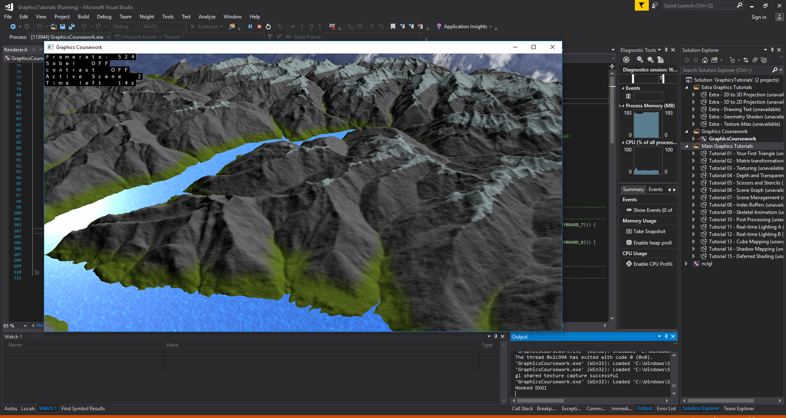

Figure : The First scene showing real time shadows. While the hellnight is partially getting up

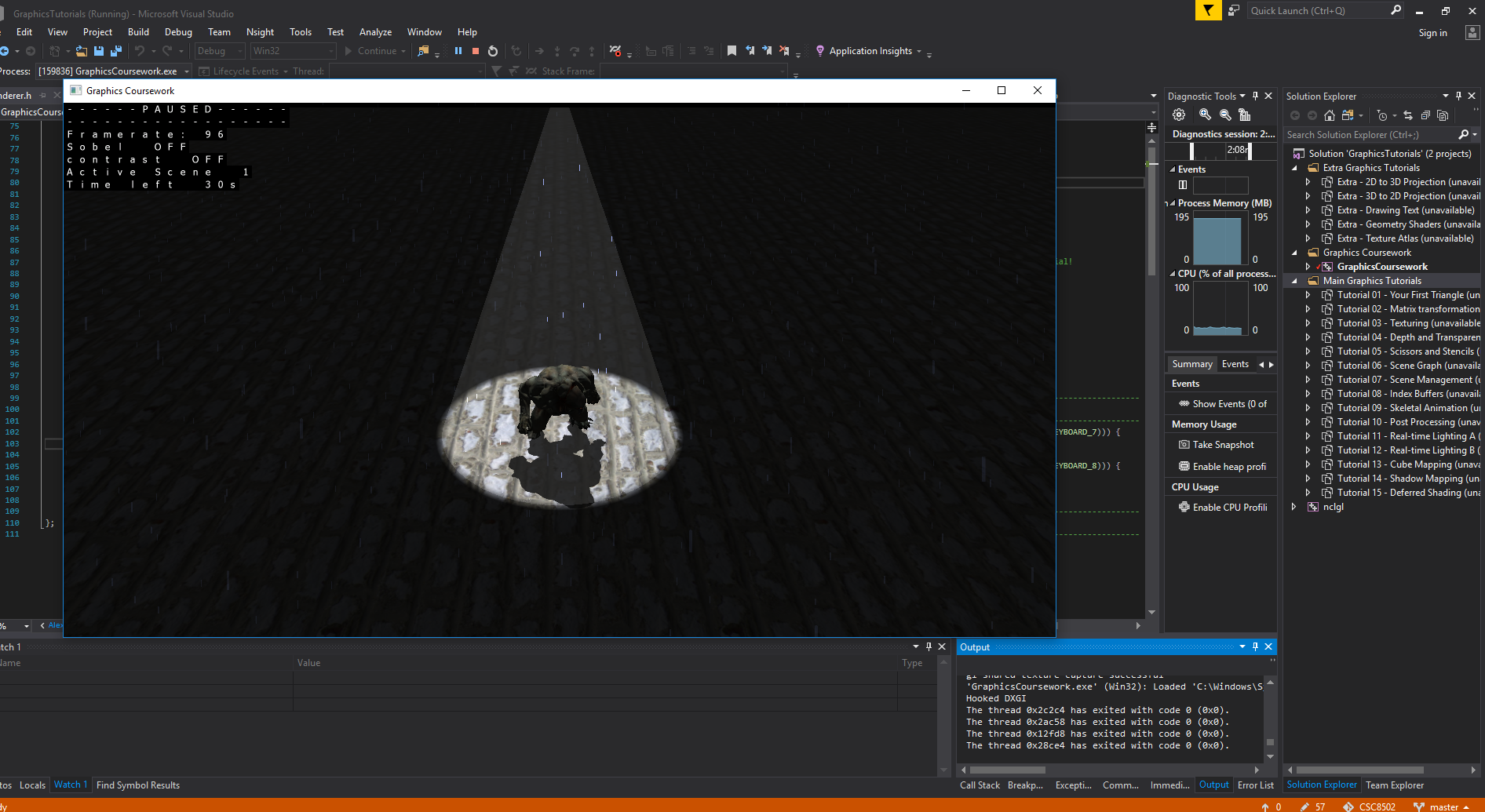

Figure :The Mountain Scene (Scene 2) with both post processing effects on

